**Collection of the first seminar**

Topic:

The position of the social services system in the national economy CR, the EU and individual countries involved in the project. Impact of the recession on the scope, intensity and quality of services

17. – 18. 6. 2014, Brno

Content

1. Basic information about the project 3

2. The current situation on labour markets in the Czech Republic, the European Union and in partner countries. Tasks of the Labour Office CR in the social field 6

3. Activity of the Verein Family Business in the social field in Austria 15

4. Employment in social services in the Czech Republic 17

5. Social services in the South Moravian region 21

6. Social services in the city of Brno 27

# Basic information about the project

RNDr. Jiří Fukan, Ph.D.

**Project partners**

Labour Office of the CR_ Regional Office in Brno(Czech project promoter)

Labour Office, Social Affairs and Family, Bratislava, Slovakia

Ing. Jarmila Boháčová, Ing. Alena ČemanováIng. Jarmila Boháčová, Ing. Alena Čemanová

T-Systems International GmbH, Germany, Tomáš Krebs,

Family Business, Austria,Alice Pitzinger-Ryba, Marlene Schmalz

Arbetsformedlingen, Sweden, Clas Olsson, Jan Sundqvist

**Project Team**

* Project manager: RNDr. Jiří Fukan, Ph.D.
* Financial manager: ing. Jiří Šimbera
* Project coordinator: Bc. Dagmar Adamcová
* Expert supervisor: RNDr. Josef Pitner, Ph.D.
* Accountant: Dagmar Rylichová
* Asistent: Mgr. Lenka Navrátilová

**Aims of the project**

* Establishment of a thematic network
* Arrangement of three specialized workshops to exchange know-how of the tasks that the partners provide
* Arrangement of three specialized workshops to exchange know-how of the tasks that the partners provide
* Organization of the final international conference
* A handbook of good practice

**Target group of the project**

* Labour office of the CR
* Specialists and managers - LO CR staff, regional offices in Brno, a total of 50 employees are to be supported
* Social partners (Chamber of Commerce, nonprofit organizations)

**Project schedule**

* Project duration: 1.7.2013 – 30.6.2015
* Workshops:

06/2014: The position of the social service sector in the national economy in the Czech Republic, in the EU and in individual countries involved in the project. Characteristics of the current state and the estimate of future development. The impact of the recession on the extent, intensity and quality of services.

10/2014: The provision of social services - the main principles of functioning of these services in each partner country, the main shortcomings and the main benefits of 'national' approaches. The tasks of public administration and regional authorities in this fieldinitiatives of NGOs and their abilities to effectively operate in the area of social services. Social services and public budgets.

01/2015: The status of labour offices in the social service system in the partner countries. Possibilities of co-financing the social services by the active employment policy. The possibility of retraining the unemployed to work in social service sector.

05/2015: The final conference.

**Introduction of the project partners:**

The company **T-Systems International GmbH in Germany** gradually established itself as a major supporter of social and health services. It creates a social and health area of ​​innovative methods, which are mainly based on the use of modern information and communication technologies. It is clear that social and health services require new challenges, mainly due to more efficient work processes and reducing invested state funds . New technological possibilities open up many opportunities for preventive care and nursing. Health insurance companies reduce their administrative costs by using electronic devices instead of paper costs, but thanks to electronic devices, doctors have access to patients´ information whenever and wherever they need. The technology therefore helps to make life safer and more comfortable in old age. It turns out that digital data help support processes, accelerate work processes and can reduce costs and improve the quality of social care. Using a wide range of IT applications provide optimum benefits in the social field.

The Austrian organization **Family Business** is an important association dealing with issues of childcare. They advise parents and analyze existing childcare facilities and also provide in Austria a unique and comprehensive overview of services for parents and their children. This database is updated and supplemented. The organization also comes up with from innovative proposals and solutions to the problems of family and social policy. Family Business also arranges babysitting au-pair. It continues in their activities so far with the support of the state (tax relief for families and care providers) and other organizations active in the social sphere. The organization deals with families, children and seniors comprehensively, whether we talk about support, counselling or education for all ages. It promotes communication and assistance between generations in the family and society as a whole.

**Arbetsförmedlingen** is the labour office in Sweden. Its mission, long term goals and tasks are set by Parliament and the government and they are formulated in the instructions for the labour office, which states that Arbetsförmedlingen is responsible for public employment services, for the implementation of employment policies and it participates in performing tasks in the social sphere. The general objectives of Arbetsförmedlingen are to work on improving the situation on the labour market in particular through effective matching candidates / job seekers with vacancies (ie. Matching active) prioritizing persons disadvantaged in the labour market, involvement of other stakeholders in order to get the applicants / job seekers back to work (local partnerships) and help to increase employment in the long run. Arbetsförmedligen has been dealing with the issue of social services, which in Sweden have a very long tradition.

**Office of Labour, Social Affairs and Family in Bratislava** (ÚPSVaR in Bratislava), in accordance with the Employment Services Act no. 5/2004, permanently monitors the current labour market conditions, creates appropriate analyses and watches indicators of unemployment and provides effective measures leading to its permanent reduction.

It also carries out a wide range of activities related to job placement, keeps records of job applicants, conducts information and advisory services, expert counselling and other additional services in the area of ​​employment. More than half of employees have social issues in their job description and provides a wide range of social services.

# The current situation on labour markets in the Czech Republic, the European Union and in partner countries. Tasks of the Labour Office CR in the social field

RNDr. Josef Pitner, Ph.D.

1. **The range of human resources in each partner country**

* The European Union centralizes developed countries, i.e. countries in which a process called demographic aging has progressed significantly.
* The share of the preproductive segment of the population (ie. persons under the age of 15 ) constantly and rapidly declines, the share of the productive segment is slightly decreasing too (i.e. 15 - 64 years) and the segment of the retired is growing very rapidly (persons over 65).
* The population of the Union has gradually gained significantly regressive character, which will result in a substantial decrease in the number of population in the near future. From the demographic and macroeconomic point of view this is a very negative development.
* The rate of economic activity in the European Union for the last 12 years has increased by 2.7 percentage points (pp) and in 2012 it was 63.8%. Of the monitored partner countries the highest rate is currently in Austria (67.2%) and Germany (67.1%), followed by Sweden in the third place (66.3%), the Czech Republic with a value of 63.5% and finally Slovakia (63.0%). For comparison: across the European Union the measure of economic activity is currently the highest in the UK (71.1%) and lowest in Italy, which has reached the value of 51.5%.
* In terms of national economic point of view the importance of the level of employment is considerably greater than the rate of economic activity. In the age cohort between15-74, it reached the average value of 57.1% in the EU in 2012. The highest was in the Netherlands (67.1%) and Sweden (65.5%), while the lowest was in Croatia (43, 3%) and Greece (45.2%). Of the monitored partner countries the highest rate of employment shows Sweden (65.5 %.), then Austria (64.3%) and Germany (63.4%) and the Czech Republic has an above average value of this indicator (59.1%; which is 2.0 percentage points above the EU-wide average). it is considerably low in the Slovak Republic (54.4%).

**The range of HR in EU**

* According to data from the Labour Force Survey there was a total of 217 510.7 thousand workers employed in the European Union (EU 28) in 2012 , of which 118 390.3 thousand were men and 99 120.4 thousand were women.
* Over the last 12 years, the number of employees has increased by about 7.0%, in the group of men only by 2.7%, while in the group of women by 12.5%.

Tab. 1: Development of the total population in the European Union in the years 2000-2012**Source**: Eurostat, 2013

1. **Status and structure of employment in each partner country. Development after 2000.**

**II.1. Developement in the sectoral structure of employment (NACE)**

* To December 31, 2012, the primary sector of the economy (agriculture, forestry and fishing) contributed to the total employment in the EUby 5.0%, the share of the secondary sector was 25.1% and the tertiary sector reached 69.3%.
* After 2000 the number of people employed in the tertiary sector has been dynamically growing in the Union, while employment in the other two sectors of the national economy has continued to fall.

Tab. 2: Development in the sectoral composition of employment in the civil sector of the national economy in the European Union in the years 2000-2012

**Source**: New Cronos, Eurostat, 2013

**II.1. Shift in the sectoral structure of employment (NACE)**

Tab. 3: Change in the number of employees in selected sectors of NH in European Union countries over the years 2000-2012

**Source**: New Cronos, Eurostat, 2013

**II.2. Development in education structure of employment (ISCED)**

* In the economic base of the European Union there are now employed:
  + 67 million workers with university degree (i.e. 30.8% of all employed persons)
  + over 105 million workers have secondary education including apprenticeship certificates - (i.e.. 48.7%)
  + about 44 million employees (i.e. 20.2% of the total) have only basic education.

**II.2. Development in education structure of employment (ISCED) after 2000**

Tab. 4: Development in the structure of employment according to the level of education in the civilian sector of national economy in Central European countries during the years 2000-2012

**Source**: Eurostat, 2013

**II.3. Development in employee ´s structure (ISCO)**

Tab. 5: Representation of the individual occupational categories (ISCO 88) of total employment in the EU countries (average status for year 2012)

**II.4. Share of women in the labour market**

Tab. 6: Development of the share of women employed in the national economy in the European Union countries in between 2000-2012

**Source**: Eurostat, 2013

1. **Status and structure of unemployment in each country. Development after the year 2000**

Tab. 7: The unemployment rate in the European Union countries between 2000 - 2012 (in the age cohort 15-74 ) – in total

**Source:** New Cronos, Eurostat, 2013

**III. 1. Development of unemployment during the last 12 months**

Tab. 8: Unemployment rates in selected EU countries during the last 12 months (harmonized unemployment rate) – in total

**Source**: Eurostat, 2013

**IV. Tasks of LO CR in the social area**

**Generally services are divided into:**

* **market services** that can be exchanged for money in the market and
* **non- market services**, which are distributed through non-market mechanisms. These include services of general interest, which means public market services, and other services provided by non-profit organizations. These services are not paid for at all or they are pay prices that are subsidized from public funds

**Social services**

* Social services are a part of the public services segment.
* Legislatively they are defined as a part of the so-called. social support, which in addition to social services include financial allowance and benefits in kind, by which are secured citizens in material need
* The aim of social services is to improve the quality of life, possibly inclusion of disadvantaged persons into the society
* They are an important instrument of social policy and one of the basic tools of social support
* They are provided to citizens who are in difficult social situations such as social exclusion, limited abilities of a citizen to solve problems due to their health condition, age, or lifestyle.

**Social services in the EU concept**

As market services granted to a specific person includes:

1. Social assistance services
2. Services in the field of education and employment
3. Social housing and long-term care

**Social services in the CR**

The founders of social service facilities in the CR can be:

* + MLSA CR
  + Municipalities or regions
  + Non-governmental organizations
  + Private legal entities and natural persons
  + Regional branches of Labour office only deals with the issues of care allowances in the area of social services. However, their policy of subsidies can be vital.

# Activity of the Verein Family Business in the social field in Austria

Alice Pitzinger-Ryba, Marlene Schmalz

**We solve all your problems intend to childcare in whole Austria**

* Family Business was founded in 1999 as a result of an European network, which dealt with projects concerning work-life balance
* It analyses the situation of childcare in Austria and searches and collects addresses of childcare
* The homepage of this association is www.kinderbetreuung.at, there families can find addresses of all childcare institutions and babysitters.
* on this homepage you can find 10.913 addresses of childcare institutions on the data bank
* now we have also a new common homepage with the Network in Spolecne (Brno):www.familyinfo.eu
* The aim of this common homepage is an whole European network where everybody can find on their own the individual childcare, which they really need

**Babysitting:**

* Family business has 1252 Babysitter in the data bank, who are Students, child-minders' and grannies to “rent”
* A Certificate babysitting courses is not a must have, but for families it is a benefit, because if the babysitters have a official babysitting course certificate the cost for Babysitting can be reduced, because you can offset the money for childcare against tax up to 2.300 euro/year/child
* But therefore the condition is the qualifying of the babysitters

**Au-pair**

* Family business has, as a NGO, a special permission from the ministry of economics to deal with Aupairs
* An Aupair can stay up to 12 months and has to help in the household and has to take care after the children
* This person works 20 hours/week and gets therefore 450 €/month/ , in addition he ore she has 5 weeks holidays

**Childcare during the holidays**

* Family business also organizes the childcare during the holidays. In Austria we have 12 weeks holidays/year , 9 weeks during the summer.
* For parents this becomes a problem, cause the schools are closed, and so they have no care for their children. I
* Family Business offers some childcare for children between 6 and 12 years
* Family business develops holiday programs which are fun oriented,

sports and adventure

**New Project:**

* Now family business has a New project, which aim is the childcare for the smallest one.
* It is the aim of Barcelona that there should be childcare for 33% of children under three years
* So Family business is developing a system of evaluation for the childcare under three. And will start a pilot project like in Mistelbach in connection with Brünn
* The plan is to Build up a kindergarden with small groups and special infrastructures for the smallest one, which is supported by goverment
* Finally there will be taking place an Evaluation and implementation of this project by the University of Krems (Danube University) and the Maserik University in Brnointhe course of an ETZ-Project in the new period 2015-2020.

# Employment in social services in the Czech Republic

Mgr. Ondřej Hora*,* Ph.D.

**Procedure and data sources**

* Two studies conducted at FSS MU (NeuJobs)
* Data sources: international comparisons, National resources - Eurostat, CSO, Eurofound (LFS, EWCS, SES)
* Time development: NACE rev. 1.1, NACE rev. 2 HSW
* (Health and social work) - a problem that there are very few data on social services available

**Context**

* Growth of 4.2 million jobs in health care and social services in the EU in less than 10 years (2000-2009)
* Significant growth in work places in most EU countries, more social services
* Nearly 90 percent of jobs in HSW. the so-called old Member States
* A small sector of Central and Eastern Europe and the southern states (Romania, Portugal)
* Expenditure on social security CR 19.5 percent of GDP, EU average of 28.2 percent of GDP (2010)

**The Czech Republic- employment**

* Growth in the number of jobs in the HSW sector in 2000-2010 by 18.7 percent (more in the years 2000-2005)
* Most new jobs are full-time jobs
* About 330 HSW 000 places in 2010 (Eurostat)
* HSW share in total employment is 6.9 percent (vs. e.g. 12.1 percent in Germany, Denmark 18 percent)
* Of which activities of social work are about 27 percent (17.7% residential services, 9.4% social work without accommodation)
* CR by the size in the sector of social services in employment the CR occupies 16 to 19 place in the EU27

**Social services - public sector**

* In the Czech Republic the predominance of the public sector in social services (80% by EC2008)
* Growth of HSW 2000-2010 by 27% in the public sector and by 12.5% in the private sector
* Employment in HSW (vs) during the financial crisis probably did not decline

|  |  |  |  |  |  |
| --- | --- | --- | --- | --- | --- |
| **CZ NACE** | **2006** | **2007** | **2008** | **2009** | **2010** |
| HSW | 251,1 | 251,6 | 256,1 | 258,5 | 267,3 |

Source: ČSÚ (over 25 employees)

**The Czech Republic – workers**

* The high proportion of women (85 percent - LFS). Most of the new jobs are filled by women in HSW
* The workforce is aging in HSW, the proportion of workers over 50 years is growing- 26.3% in 2000, 31.3% in 2010 (one of the highest in the EU)
* Education of workers is mostly of middle level (ISCED 3 and 4) (69.1 percent). Differences by gender and age. More often education outside the main field (engineering, industry - 18%)
* Very significant decrease in the absolute number of young workers 2000-2010

**The structure of the HSW workers by gender, age and level of education (LFS, Eurostat, own calculations)**

|  |  |  |  |
| --- | --- | --- | --- |
| **Education** | **Terciary** | **Secondary** | **Primary** |
| Men | 47.8 | 49.3 | 2.9 |
| Women | 20.3 | 74.2 | 5.5 |
| Aged15-29 | 34.8 | 63 | 2.2 |
| Aged 30-49 | 25.1 | 71.7 | 3.2 |
| Aged 50+ | 23.6 | 67 | 9.4 |
| Total | 25.9 | 69.1 | 5 |

**The Czech Republic – work places**

* The share of temporary employment jobs (6.2%) is average in relation to other NH sectors
* The proportion of part-time jobs in HSW is 9.2 percent

**Quality of work life - EWCS (EU)**

* Overall favourably evaluated
* Increased shift-night and weekend work
* Quite often physically and mentally demanding (eg. lifting persons in direct contact with clients)
* More likely to report stress, fatigue, sleep problems, anxiety and depression
* Some foreign studies report more frequent fluctuations (e.g. care of the elderly)

**The Czech Republic – wages (SES, MLSA)**

* The average wage in HSW is about 90 percent of NP
* Big differences within the HSW - the least paid workers of social welfare, qualified social workers are better paid (MLSA)
* They are paid less than workers in industry (SES)
* Young workers are paid worse
* It also applies to the public sector (national data)

|  |  |  |  |  |  |
| --- | --- | --- | --- | --- | --- |
| **EURO/YEAR** | **WOMEN** | **INDUSTRY** | **PST\*** | **Low gual.** |  |
| **12 154** | **- 7,2** | **- 7,1** | **41,8** | **- 33,4** |  |
| **EURO/YEAR** | **till 30 let** | **aged 30-39 let** | **aged 40-49 let** | **aged 50-59 let** | **aged 60 plus** |
| **12 154** | **- 13,6** | **- 1,4** | **1,5** | **2,4** | **17,6** |

Source: SES

* Professional, scientific and technical activities

**Conclusions:**

* The number of jobs in social services (HSW) was not much affected by the financial crisis
* The growth in the number of jobs in the care of the elderly
* Modest growth in number of workers in nurseries
* Opportunity for employment growth in the future? (has grown strongly across the EU)

Identified risks:

* Sustainability of jobs (funding)
* Lack of interest in working in social services
* The reduction in the average level of qualification (discussion)
* Illegal employment , foreign workers

# Social services in the South Moravian region

Mgr. Martina Blešová

**Legislative framework**

The Social Services Act(108/2006 Sb.)

Roles of the region:

* Conditions for entry (registration) + (financing) + development planning of social services (needs, specifics, available resources, interconnection services, national and European strategies)
* cooperation with key actors in the field of social services (MLSA, communities, providers, users)

**Registration of social services**

* A condition for operating social services is the registration at the regional office - a decision on the basis of a written request. At present there are 520 registered social services in the SMR.
* These services are provided by 168 service providers - including 93 providers in the legal form of NGOs.

**Financování sociálních služeb v JMK**

|  |  |  |  |
| --- | --- | --- | --- |
| **Social service** | **No. in SMR** | **Social service** | **No. in SMR** |
| social counselling | 70 | field programmes | 13 |
| care service | 64 | sheltered housing | 10 |
| homes for the elderly | 46 | social services provided in healthcare facilities | 8 |
| special regime homes | 32 | contact centres, dormitories | 7 |
| respite services, SAS for seniors and persons with disabilities | 29 | social therapeutic workshops | 6 |
| day care centers | 26 | weekly care centres, emergency assistance, NDC | 5 |
| asylum homes | 23 | DPC, aftercare services, telephone emergency assistance, interpreter services | 4 |
| social rehabilitation, SAS for families with children | 20 | guide and reader services, early care, therapeutic communities | 3 |
| DOZP, day service centres, NZDM | 18 | promoting independent living, intervention centres | 1 |
| personal assistance | 17 | Source: Registr poskytovatelů MPSV | |

**Funding of social services in the SMR**

Subsidies from the state budget of the Czech Republic redistributed by MLSA

430 services supported by the amount of 666.9 mil. CZK for the year 2014

**Funding of PO SMR**

* contribution of the founder - 112.4 mil. CZK

**Funding of NGOs**

multi-annual subsidies from the budget of the SMR: 2014: CZK 51 mill.

**The funding of social prevention**

* IP „Provision of selected social prevention services in the SMR„
* 80 services
* 590,3 mil. CZK from the ESF and the state budget

|  |  |  |  |  |
| --- | --- | --- | --- | --- |
| **Sources of income** | **Field** | **Ambulatory** | **Stay** | **Professional social  counselling** |
| **Income from clients** | **28,3** | **8,9** | **48,2** | **0** |
| **MLSA** | **24,9** | **20,3** | **21,5** | **40,6** |
| **Contribution of the founder** | **15,5** | **11,5** | **16,0** | **19,2** |
| **Municipality, municipal authority** | **14,8** | **6,3** | **1,4** | **10,0** |
| **SMR** | **6,9** | **11,0** | **2,9** | **6,8** |
| **Structural funds of EU** | **4,7** | **28,1** | **3,1** | **6,2** |
| **Other sources** | **1,6** | **8,0** | **2,7** | **3,0** |
| **LO** | **1,0** | **1,4** | **0,6** | **0,4** |
| **Foundation** | **0,8** | **0,5** | **0,1** | **0,8** |
| **Other fields** | **0,8** | **1,9** | **0,1** | **5,9** |
| **Donations** | **0,7** | **2,1** | **0,7** | **4,3** |
| **Funds ZP** | **0** | **0** | **2,7** | **0,2** |

**Funding of social services in the SMR**

* Changes in evaluation and financing of existing social services - measurable criteria, objectification of costs, streamlining of decision-making system of financing
* The methodology of evaluation of social services in relation to social services network optimization in the South Moravian Region.

- *takes into account both quantitative and qualitative criteria*

*- allows to compare the performance of individual services based on predetermined criteria, which are attributed to adequate weight*

*- sets basic requirements for the quality and efficiency of services in the region*

**Planning social services in the South Moravian Region**

* Medium-term plan for the development of social services in the South Moravian Region 2012 – 2014
* *„necessity, quality, long-term sustainability "*
* Specific implementation: one year action plans
* The aim of the action plans: linking the outputs from the process of planning social services and systems of subsidies for social services.

**Planning social services in the SMR**

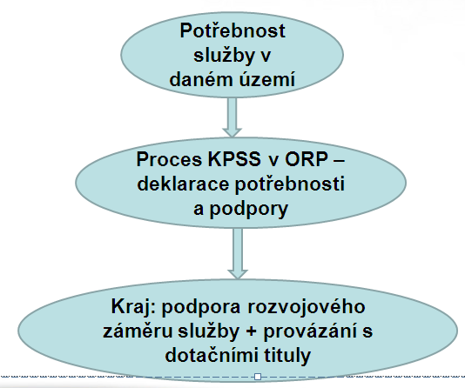

**Action plan of social services development in the SMR for the year 2015**

* Minimalization of development activities, stabilization of the service network being the priority
* Supported development – selected long-term planned intentions, whose realization falls in the year 2015
* Condition - accordance with community plan ORP + co-finincing new social sevices

**Another direction of social services in the SMR**

* transfer of subsidy competencies of MLSA to the regions from January 1st, 2015
* termination of financing 80 prevention services from IP: optimization of the network of social prevention
* implementation of the project "Support for planning the development of social services in the South Moravian Region III.„
* benchmarking of social services
* preparation of the Medium-Term Plan for the Development of Social Services for the period 2015 – 2017
* optimization of consulting services network and social care - district teams

# Social services in the city of Brno

Mgr. Věra Muthová

**The city of Brno: socio – demographic data**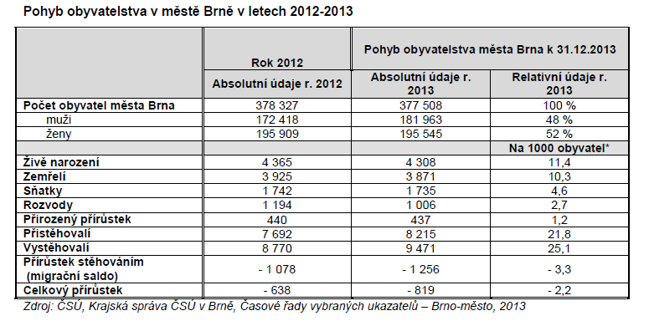

population movement in Brno to 31st Dec 2013

Population

Men

Women

Born (alive)

Died

Divorces

Natural population increase

Immigrants

Emigrants

Migration balance

Overall increase

Social problems and social sector development are dependent on the demographics of a territory, also in Brno as elsewhere the phenomenon of aging population shows, greater proportion of women than men and a higher proportion of students in regard to the representation of high schools and academies in the city is also typical of Brno.

**Act on social services**

**Act 108/2006 Coll. from 14th March 2006 on social services**

Change: 366/2011 Coll. (part), 261/2007 Coll. (part), 303/2013 Coll. 313/2013 Coll.

**Basic types and forms of social services § 32**

a) social counselling = according to § 37 basic social counselling gives people necessary information to solve their difficult social situation;

b) social care services = in accordance with § 38 examples of services: day care, retirement homes, special homes, personal assistance, sheltered housing, daily and weekly clinics, emergency care, etc.;

c) prevention of social services = in accordance with § 53 examples of services: shelters, hostels, field programs, social - activation services for different target groups, halfway houses, early care, social rehabilitation and more.

**Forms of providing social services** § 33

1. Residential: services related to accommodation in social services;  
2. Outpatient: services for which the person is or is accompanied by, is not part of the service of accommodation;  
3. Terrain: services that are provided to people in the natural social environment of clients.

**Care allowance - Decree no. 505/2006 Coll.**

The contribution is intended for persons who, due to long-term medical condition need assistance of another person in self-care and help to ensure self-sufficiency. With such a contribution these people will be able to pay for the care they need.  
The contribution brought many changes and is based on the philosophy of client´s authorization, though it brings about a number of complications and unexpected consequences. In 2012 social investigation among clients and the payment of contributions for care was passed within the competence of labour offices.

**Social care in the city of Brno**

The mission of social work is to provide assistance to citizens in difficult social situations. Statutory city of Brno divides powers between the city and the 24 boroughs.

**The following institutions and organizations provide social services in Brno:**

* Statutory city of Brno - Department of Social Welfare Brno City Municipality and day care centers in the city district offices  
  • contributory organization established by the city  
  • NGOs

In Brno 88 organizations and 237 registered soc. services provide social services for the year 2013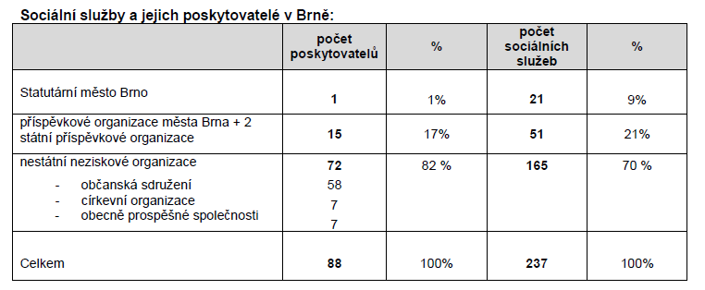

Statutory City of Brno no. of providers no. of social services

Contributory org. Of Brno city

NGO - civic association

-church organization

-public benefit corporation

Total

**Social services in the city of Brno**

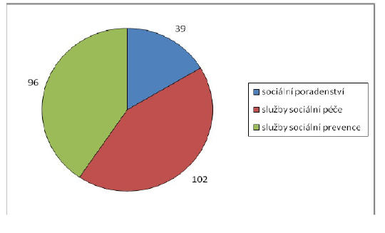**According to the register of providers of MLSA there is a total of 237 social services (2013) registered in Brno:**

social counselling = 39

social care services = 102

prevention of social services = 96

Social services according to individual target groups:

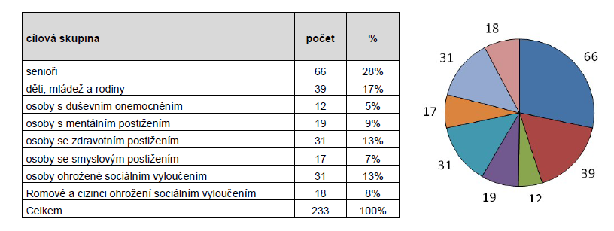

Seniors

Children, youth and families

Mentally ill persons

Disabled persons

People with sensory impairments

Persons threatened with social exclusion

Romanies and foreigners threatened with social exclusion

**Planning of social services**

**Social services community planning is a way of planning social services at a municipal or regional level to suit local specifics and needs of individual citizens**

**The mission of the community planning is to ensure that social services are:**

* available (capacity, place, time ...)  
  • quality  
  • respond to the needs of users  
  • offer services that are clear and understandable  
  • money is spent only on services that are needed

**CPSS is a compromise between needs and resources to meet the requirements**

* clearly describes the existing network of social services  
  • priorities are usually development areas   
  • implementation is based on multisource financing

**Within the planning of social services Brno city cooperates closely with the South Moravian Region.**

Specifics CPSS in the city of Brno:

* hinter-land area
* coherence CPSS and financing of social services
* portal of social care: www.socialnipece.brno.cz
* Socio-info Counselling Center (SIC):
* the launch on 1 October 2009 under the OSP MMB (Department of Social Welfare Brno City Hall
* Its aim is to provide comprehensive information about the offer of social services and provide personal, telephone and internet counselling from social areas and help in difficult situations
* In 2013 couselling was provided to 5,759 clients

Main targets of the 3rd community plan:

1. effective, quality and affordable social services  
2. **support and maintain existing social services network**3. possible development according to priorities and measures

**Financing of social services in Brno**

It is important to realize the cohesion of the Community Planning of Social Services (CPSS) and the financing of social services, planning is carried out in close cooperation with social service providers. The outcome is to establish minimum and optimum network of social services. This network should ensure some stability to high-quality providers.

* Financing of social services is **multi-source** (subsidies from the city budget is only one of the sources) and it runs in accordance with the approved medium-term planning documents of social services development.

Financial sources:

* **BRNO – Department of Social Welfare of Brno City Hall**
  + subsidies on social services for NGOs - program I.
  + subsidies on additional services for NGOs - II program
  + contribution of the establisher of an organization
* **MLSA** grant proceedings to social services
* **SMR** grant proceedings to social services
  + **IP I.** Selected social prevention services 2009 – 2011
  + **IP** **II.** Selected social prevention services 2012 – 2014
* **Structural funds of EU** (OP LZZ, OP VK, ROP, IOP)
* **Other sources:** Labour Office, payments by users, health insurance funds, domestic and foreign foundations, donations, membership fees and others.

Financing of NGOs runs in accordance with the approved medium-term planning documents of social services development.

**Expenditure on social welfare in 2013 (in thous. CZK):**

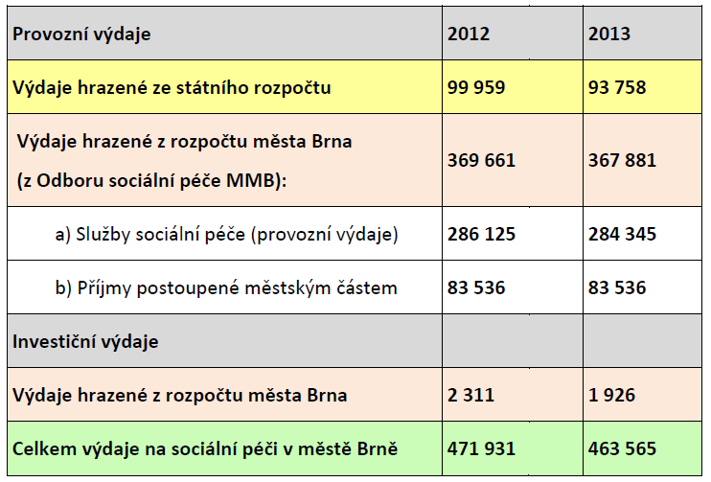

operating expenses

expenses paid from the state budget

expenses paid from the budget of Brno city

1. Social service care
2. revenue advanced to city districts

capital expenditure

expenses paid from the budget of Brno city

total expenses on social care in the city of Brno

Providing subsidies from the city budget goes along with updated *"Guidelines for the provision of subsidies from the budget of the City of Brno"* a *"Rules for the provision of subsidies from the budget of the city of Brno"*

**Subsidies for social services from the city budget**

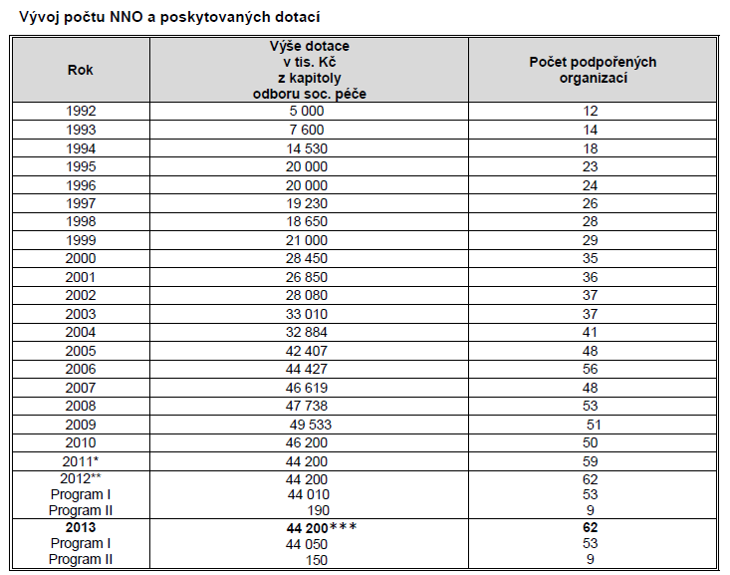

**Current needs alias "unresolved areas"**

* The issue of people with multiple diagnoses - the need of specific services that are expensive to acquire and operate.  
  • Problems also arise due to inter-ministerial position of services.  
  • The need to increase awareness of the complex social services, including information from other areas that are related to social services  
  • Employment of persons with disabilities and persons at risk of social exclusion, including the issue of social entrepreneurship • The issue of the lack of social services for specific target groups with the so-called combined diagnoses.  
  • Tackling the housing problem with accompanying social services for specific target groups  
  • Ageing carers  
  • Tackling the issue of carers, burnout syndrome and devastation of caring families  
  • The need for linking social and health services.  
  • The challenge of overcoming barriers and others.

**Development trends**

* Options within the foreseeable financing;
* prevention support;
* emphasis on maintaining of the support for clients in their natural environment;
* this is related to the transformation of social services;
* innovation - e.g. through shared housing and other;
* linking ministries (social × health services, but also housing, education, etc.).
* amendment of the Act on social. services and others.

Elaborated by:

Mgr. Věra Muthová, muthova.vera@brno.cz

Community Planning Department of Social Services   
Department of Social Welfare   
**Brno City Hall**   
June 2014

The document serves as a basis for the seminar of the Labour Office, the regional branch of Brno, to the project "Innovation in Social Services." The seminar was held on the 17th and 18th June 2014 and the topic was: "The position of the social service sector in the national economy in the Czech Republic, in the EU and in the individual countries involved in the project. The impact of the recession on the extent, intensity and quality of provided services."

Sources:  
Report on social care in Brno in 2013  
3rd Community Plan for Social Services of City of Brno for the period 2013-2015  
Action Plan for Social Services in Brno 2013  
Czech Statistical Office  
Portal of social care in Brno:www.socialnipece.brno.cz